**Customer & Community Engagement Lead**

**Unity Housing Association**

**Applicant Information Pack**

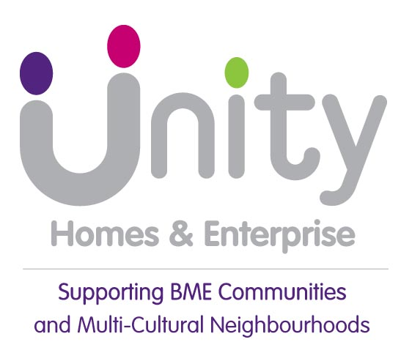

Hello!

Thank you for having an interest in working for Unity.

We are a successful, independent and ambitus housing association driven by social purpose, supporting BME communities and multi-cultural neighbourhoods across Leeds and Kirklees.

We are proud to call ourselves a BME association, part of the national BME housing movement, and believe that is as important today as it was when we were founded over 35 years ago.

Our social purpose is at the heart of everything we do, it states: ‘we will fight inequality and empower BME people to improve their lives by creating opportunities and helping to regenerate communities’

The role of Customer and Community Engagement Lead is a great opportunity to join a team that not only supports people but wishes to improve and drive the business forward.

We are looking for someone who is hands on, creative and can use ideas to enhance community involvement. Someone who can problem solve and decision make.

If you are confident you can deliver in that environment and are up for the challenge, then we’d love to hear from you.

I believe this is a brilliant opportunity to make a difference and I look forward to receiving your application.

Yours sincerely



Cedric Boston

Chief Executive

**Customer and Community Engagement Lead**

**Reports to:** Housing Services Manager

**Working Location:** You will be based at our office at 113-117 Chapeltown Road, LEEDS,

LS7 3HY.

**Salary:** £35,000 per annum

**Hours of Work** 35 hours per week, to be worked over Monday to Friday

**Benefits:** 27 days leave plus bank holidays, Occupational Pension Scheme, flexible working and family friendly policies.

**Job Purpose:**

To develop, support and empower our customers voice in influencing Unity’s services and improving the communities where our homes are.

The will ensure Unity’s customers are at the heart of service design and delivery. Helping to deliver our strategy, the post holder will develop inclusive and innovative ways in which customers can influence, monitor and scrutinise our services.

They will be passionate about service excellence and a strong communicator, with the ability to influence thinking and action. Developing nurturing partnerships and networks will be essential as you will be working with individuals and groups to realise their potential and create positive change within our communities.

The Customer & Community Engagement Lead will work closely with colleagues, partners and other organisations to ensure that customer voice drives our strategic priorities and makes positive changes for customers and communities.

**Key Responsibilities:**

Understanding the communities that we work in and getting to know our customers and what they want and need from Unity.

Ensure the customer voice and influence is considered in the design and delivery of all Unity’s services and business planning.

Design, develop and facilitate innovative ways to seek the views of Unity customers to ensure representative feedback contributing towards decision making.

Take the lead in developing targeted approaches to engagement with customers who are under-represented.

Interpret, analyse and collate customer feedback, summarising and presenting information to inform decision making.

Understand and keep abreast of the latest thinking and regulatory requirements for customer involvement and co-creation of services and bring these to life.

Maintain accurate records of participation and produce reports to demonstrate impact and outcomes.

Work with individuals and groups to upskill, build capacity and source/ provide learning, training and networking.

Build strong networks within the community to ensure that Unity makes a positive contribution to the wider areas where we have homes.

Be able to initiate, lead, design and deliver effective multi-partnership projects that maximise positive outcomes for our customers and communities.

Support a diverse range of community groups and individuals to develop and flourish; contributing to our communities, making great places where people want to live.

Support the Housing Services Manager and Director of Housing Operations to deliver strategic objectives.

**What we need from you:**

Energy, passion, innovation!

Drawing out thoughts and ideas from people to create something that will positively impact the service that we provide to customers and the communities we work in.

Amplyfying the customer voice and influence into practical, outcome focussed actions that make a difference.

Embracing change and innovation, always thinking about how things can be improved.

Celebrating and sharing successes, motivating and inspiring people.

Getting things done through a practical and hands on approach, delivering multiple tasks and projects simultaneously.

Being proactive, taking ownership and responsibility for a busy and varied workload whilst spotting and maximising new opportunities.

Being confident in asking challenging questions to influence thinking and decision making.

Presenting ideas and information to a varied audience with confidence and in a way that engages people.

Working as part of a team, supporting and contributing to wider team projects and initiatives.

An understanding of the principles of excellence in tenant participation and regulatory requirements.

Experience and demonstrable ability to work in collaboration with colleagues, partners and stakeholders to create meaningful outcomes.

Strong communication skills with the ability to create engaging, clear and concise communications for a range of audiences.

Ability to analyse and interpret customer feedback and summarise or theme results to present back to services and customers.

Ability to present and communicate your reasoning to influence thinking and action.

Ability to deal sensitively and confidentially with contentious issues, finding positive solutions.

Ability to engage and build rapport with people through a variety of means, particularly groups and individuals who may not currently engage.

Ability to develop and lead dynamic partnerships and networks, keeping people on the same page and ensuring things happen when they need to.

Demonstrate a commitment to Equality and Diversity ensuring an inclusive approach to working with and engaging people and communities.

Experience of using Microsoft IT packages including Word, Excel and Outlook and the skills and confidence to learn and use other software that increases the number of methods that customers can provide feedback and get involved with Unity.

You may be required to attend meetings and address emergencies.

We positively welcome and support diversity in our workforce and welcome applications from all sections of the community.

Closing date: **17 January 2025**

To apply please submit a CV and covering letter to [recruitment@unityha.co.uk](mailto:recruitment@unityha.co.uk).

In your letter you must tell us how your experience meets our requirements for the post. Tell us why you have a passion for working for Unity and why you are the colleague we need. Whilst we are interested in your work history, demonstrating behaviours, skills, abilities and knowledge and experience can come from a variety of life experiences not just paid employment. Please feel free to use example from all areas of your life that are relevant to the requirements of the role.

Applicants will be required to bring evidence of their eligibility to work in the UK to the first interview.

