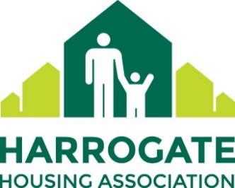

Harrogate Housing Association is looking for voluntary Board members to help it deliver its growth and regeneration ambitions whilst remaining true to its values of Local, Approachable and Customer-focussed. With growth of 30% over the next three years already secured we want Board members to help ensure the Association does not lose sight of its values and builds on improving the energy efficiency of its existing homes.

We are particularly looking for a HR professional or zero carbon retrofitting specialist, ideally from a non housing association background – getting a different perspective on things is important. We are also looking for finance and development colleagues, ideally with a housing background.

Whilst the positions are voluntary we do pay expenses and, being a financially strong organisation with an experienced well informed Board, can offer a great learning environment for a first board appointment. Enhancing your CV whilst helping the Association to succeed for its customers is a win win situation.

You can find out more about us at [www.hhal.org.uk](http://www.hhal.org.uk) or for an informal discussion contact Steven Brook, CEO, on 01423 884433.

Still interested then send in your CV with a short covering letter highlighting how you can help to [steven@hhal.org.uk](mailto:steven@hhal.org.uk) before 31 January 2025.